Poznań, 08.01.2020
2020 NAMM Show Product Preview
Zylia Sp. z o.o.
Booth 14119, ACC North, Level 1

Zylia at the 2020 NAMM Show
This year at NAMM Show 2020, Zylia will present two major additions to its industry-leading 3D audio recording and production portfolio: the ZYLIA ZR-1 portable recording device and the 6DoF VR/AR Development Kit. Designed for professional users of the innovative ZYLIA ZM-1 microphone system, the powerful new ZYLIA ZR-1 recorder offers a convenient laptop replacement for outdoor and ambient sound recordings, 3rd order Ambisonics recording, and 360-degree recording. The new ZYLIA 6DoF VR/AR system for producing 3D navigable audio empowers users to capture high-quality higher-order Ambisonics (HOA) simultaneously at multiple points around the recorded scene. The company will also enable visitors to get familiar with the newest version of ZYLIA Studio software.

NEW – ZYLIA ZR-1 Portable Recorder
“In response to user requests and feedback, we are launching a product that enables recording independent of the laptop,” said Tomasz Zernicki, Zylia co-founder and chief technology officer. “This highly efficient portable recorder simplifies outdoor recording while making 3rd order Ambisonics recording easy. With this uniquely portable and powerful solution, users have the freedom to record hundreds of hours of 360-degree audio in virtually any environment.”
Measuring 206 mm by 196 mm by 58 mm and weighing around 1 kg, the rugged ZYLIA ZR-1 fits neatly into a standard field recorder bag and requires only a USB connection to the ZYLIA ZM-1 to support audio recording. Convenient control, status, and monitoring options help users make the most of the ZYLIA ZM-1 and its exceptional recording capabilities while working in the field. Equipped with an SDXC memory card (up to 2 TB) and powered either by eight AA batteries or an external 5V power source, the ZYLIA ZR-1 allows users to record over 220 hours of 19-channel 48kHz/24bit PCM audio or around 300 hours of compressed data (Wavepack). Stored files can be transferred to other external devices to free up space on the ZR-1 for further recording.
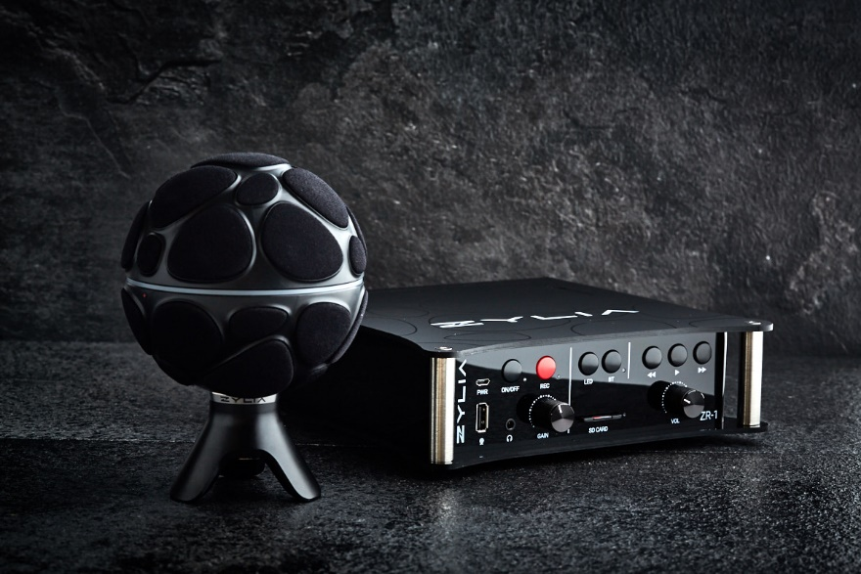
Photo: ZYLIA ZR-1 Portable Recording Device
Web page: https://www.zylia.co/zylia-zr-1-portable-recorder.html

NEW – ZYLIA 6DoF VR/AR – Recording of fully navigable audio for virtual & augmented reality
“Our 6DoF VR/AR Development Kit gives users full freedom in experimenting with different spatial arrangements of ZYLIA ZM-1 recording devices,” added Zernicki. “A complete solution for 6DoF capture, recording, and control, this new offering helps users to streamline and optimize the capture of 3D audio for virtual reality and augmented reality applications and provide a volumetric 3D audio solution.”
Created specifically to support production of six degrees of freedom (6DoF) and volumetric 3D audio experiences, the 6DoF Development Kit from Zylia allows audio engineers and creatives to place multiple ZYLIA ZM-1 devices around a sound scene to capture audio that supports truly immersive experiences with freedom of movement through the 3D space.
The 6DoF Development Kit includes nine ZYLIA ZM-1 microphone arrays and hardware driver; recording and synchronization software; exemplary 6DoF rendering application based on Unity and MaxMSP.
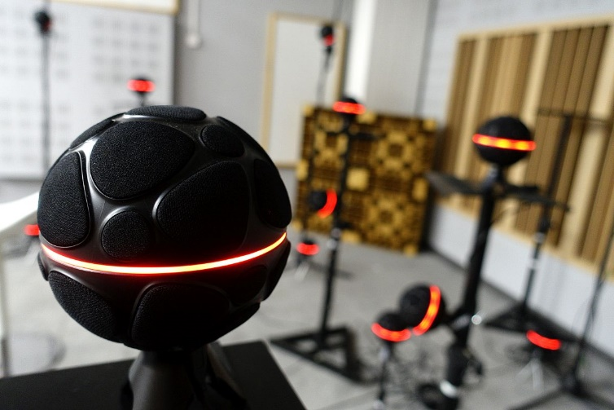
Photo: Fully navigable audio for virtual & augmented reality and volumetric audio
Web page: https://www.zylia.co/zylia-6dof.html
Additional news: https://www.zylia.co/blog/zylia-is-building-a-future-of-immersive-and-fully-navigable-audio-for-virtual-reality-by-creating-an-installation-of-53-3rd-order-ambisonics-microphone-arrays

NEW – ZYLIA Studio 2.0 - Your own recording studio simpler than ever
To support the creativity of musicians who are our current and future users, Zylia also focused on providing an even more user-friendly version of our well-known ZYLIA Studio software.
In the newest version of ZYLIA Studio software users can save more time thanks to a new workflow and automatic calibration. Instead of manual calibration musicians need only to place their instruments in a correct zone around the microphone and the dynamic energy map will help them to track their position.
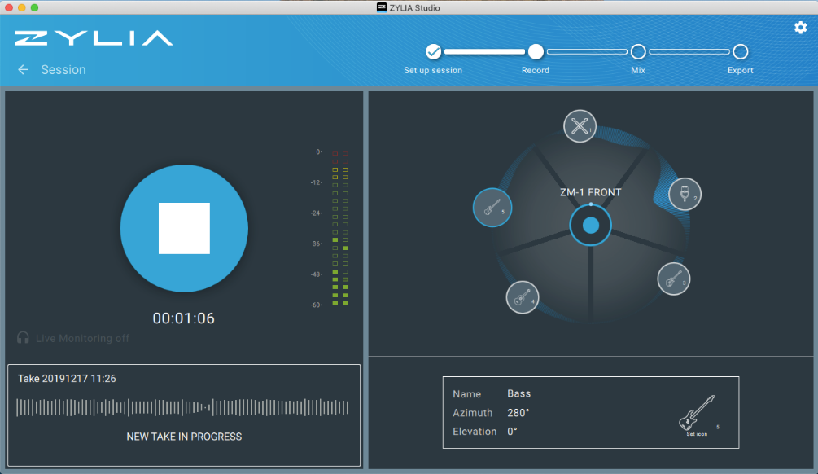
Photo: ZYLIA Studio v2.0
To reflect the well-known microphone techniques Figure 8, Blumlein Stereo, Cardioid, Stereo XY, and Mid-Side presets were added. Whereas, mixing enthusiasts will find more options to play with such as Equalizer, applied on every track, allowing to adjust the frequency response in 3 bands. In general, your mixes will sound better, because we improved sound quality even more. Now, thanks to new separation filters, your mixes will have a full audio spectrum (up to 20 kHz).
There is even more to discover in the newest version of ZYLIA Studio. All functionalities will be presented at Zylia booth during the whole NAMM Show.

Company Quote:
“At this year’s NAMM Show, we’re showcasing our innovative approach to 3D audio recording and post-processing. ZYLIA ZR-1 Portable Recording Device not only broadens our product portfolio but mainly is the answer to our customers’ needs. With the second product ZYLIA 6DoF VR/AR Development Kit we go far beyond the present 3D audio solutions and introduce Fully navigable audio for virtual & augmented reality.”
— Tomasz Zernicki, Chief Technology Officer, Zylia

Company Profile:

Zylia develops innovative, world-class recording technologies and turns them into products that improve the lives of musicians and audio creatives. With a passionate and dedicated team of almost 20 experts in music production, audio research, software, business and product development, the company crafts and delivers products with the potential to redefine and revolutionize the way 3D sound and musical performances are recorded and produced. Leveraging their personal experience as musicians and tech gurus, along with input from music and audio communities around the world, Zylia’s experts bring musicians agile recording tools that make it easy to be creative in any environment.

Zylia Contact:

Anna Czerwoniec
Marketing and Sales Director
Phone: +48 61 279 40 44
Email: anna.czerwoniec@zylia.pl
Website: www.zylia.co

