ZYLIA REMOVES THE BORDER BETWEEN MUSICIANS AND AUDIENCE!
REALISTIC, NAVIGABLE AUDIO IN A LIVE-RECORDED CONCERT
OF POZNAŃ PHILHARMONIC ORCHESTRA

POZNAN, Poland — Sep. 24, 2020 — Zylia, an industry leader in the field of 3D audio recording in collaboration with Poznań Philharmonic Orchestra shows first in the world navigable audio in a live-recorded performance of a large classical orchestra. 34 musicians on stage and 30 ZYLIA 3’rd order Ambisonics microphones allowed to create a virtual concert hall, where each listener can enact their own audio path and get a real being-there sound experience.

ZYLIA 6 Degrees of Freedom Navigable Audio is a solution that allows recording an entire sound field around and within any performance imaginable. For a common listener it means that while listening to a live-recorded concert they can walk through the audio space freely. For instance, they can approach the stage, or even step on the stage to stand next to the musician. At every point, the sound they hear will be a bit different, as in real life. Right now, this is the only technology like that in the world.

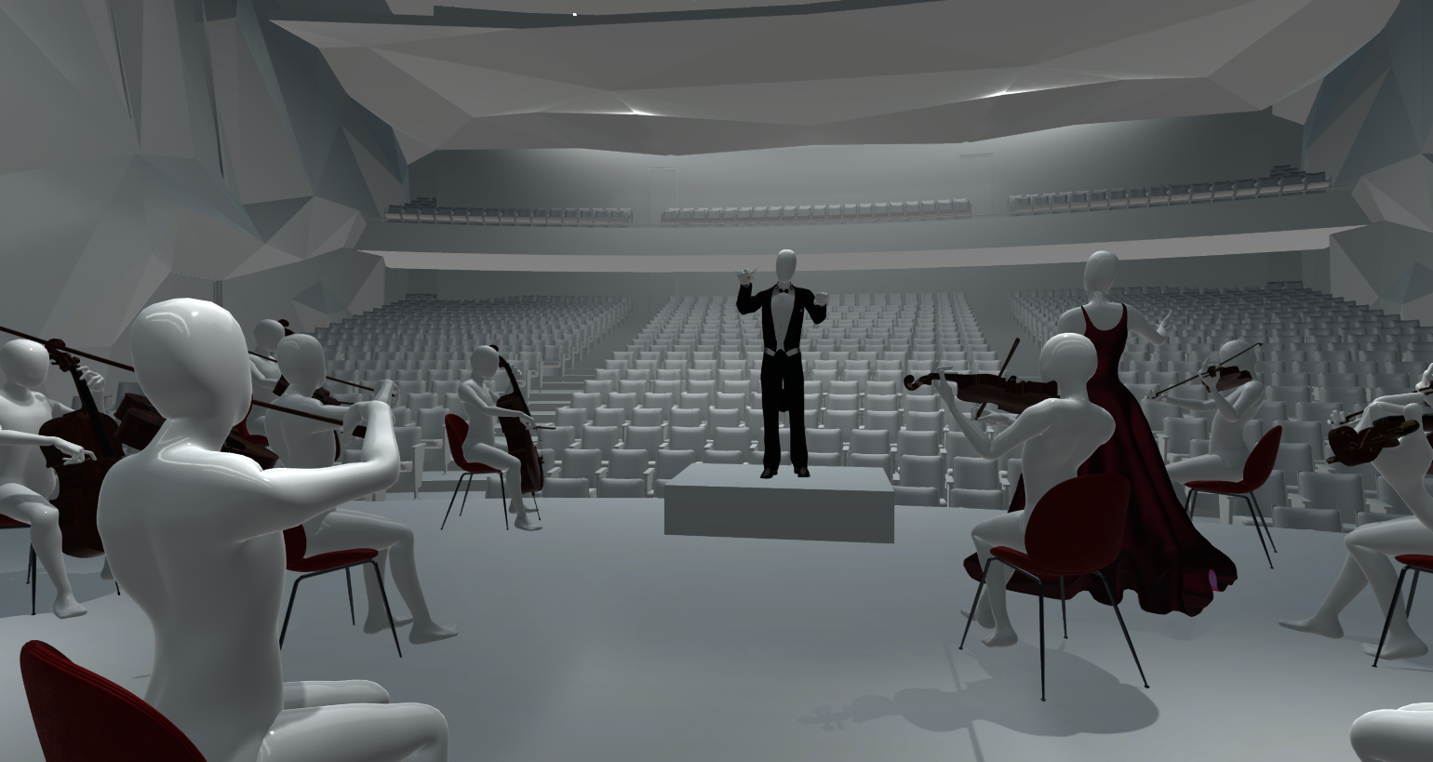
“The mission of our company is to help artists and to bring artists and their audience together. That’s why we developed this navigable audio system in 6 Degrees of Freedom – to connect them in the virtual world,” – says Tomasz Żernicki, CEO of Zylia. “When we look into the future, what we see is a completely different world of interaction with creative art. We see streaming platforms enabling people to participate in concerts of any artists they want. Platforms that they can enter from their homes and join the experience with their friends. We see hyper-realistic games, both visually and audibly, allowing players to fully immerse themselves in the plot. Finally, we see virtual reality creations, available for everybody from anywhere in the world and limited only by the imagination of their designers. ZYLIA Navigable Audio is a huge step in that direction, and we are very proud of the impact that we are having on the future of 3D audio technology,” – he adds.

The heart of ZYLIA 6 Degrees of Freedom Navigable Audio system are spherical, Ambisonics microphones ZYLIA ZM-1S with synchronisation. The 19-capsule microphone array with high-end 24-bit recording resolution allows user to record an entire 360-degree sound scene. Equipped with the digital XENSIV™ MEMS microphones from Infineon Technologies, the array delivers high-fidelity and far-field audio recording. In addition, it provides multiple-microphone noise- and distortion-free audio signals for advanced audio signal processing.

“To record the Poznan Philharmonic Orchestra performance we placed in the concert hall 30 third-order Ambisonics microphones ZYLIA ZM-1S with synchronisation. We put them on stands and placed them on the stage among musicians. The microphones have been connected with computers through simple USB HUBs. We used 2 laptops for recording and one PC Linux workstation as a backup. These 30 microphones gave us 600 audio channels – 20 for each ZM-1S. As a final result, we gathered 3 hours of recordings and 700 GB of audio data,” explains Tomasz Żernicki.

6 Degrees of Freedom in Zylia’s solution name refers to 6 directions of possible movement: up and down, left and right, forward and backwards, rotation left and right, tilting forward and backward, rolling sideways. In post-production, the exact positions of microphones placed in the concert hall are being mirrored in the virtual space through the ZYLIA software. When it is done, the listener can create their own audio path moving in 6 directions motioned above and choose any listening spot they want.

“The border between the musician and audience was existing for ages. Once you pass this border you are entering a real musical world. This kind of experience is an experience I cannot describe. You have to fill it. In the last months, we faced a problem of making concerts without a public. We've been broadcasting the concerts but it produced a lot of problems on how to show the acoustic of the hall. This is something very important in the ZYLIA system – it makes it possible to listen to the orchestra not only from one fixed place. You can go to the balcony or the last row and acoustic changes,” says Łukasz Borowicz, the Principal Guest Conductor of Poznań Philharmonic Orchestra. “I think people are very open to new technologies and notice that the experience of the sound which comes to you directly is one of the best experiences you can have. Technology seeks the possibilities to reproduce this real feeling and I think this technology which was used for our recording shows that ability,” he adds.

Zylia offers a complete solution for navigable audio and it is open for collaboration with all companies and institutions seeing its great potential in any field: music, game, VR, sport, art, academic research. Already having a great impact on the future of audio recording, the company never ceases in searching for new ideas and inspirations.

The link to the virtual concert of Poznań Philharmonic Orchestra with navigable audio:

https://youtu.be/m5YgcCSvLp4

The demo is also available in 360 version for PC VR goggles. The files can be easily downloaded and used with the PC VR headset.

See how it was done!

The link to the virtual concert of Poznań Philharmonic Orchestra making of movie:
https://www.youtube.com/watch?v=92KIUaNVwlI

# # #

About Zylia
Zylia develops innovative, world-class 3D audio recording technologies and turns them into products that improve the lives of musicians and audio creatives. With a passionate and dedicated team of experts in music production, audio research, software, business and product development, the company crafts and delivers products with the potential to redefine and revolutionize the way 3D sound and musical performances are recorded and produced. Leveraging their personal experience as musicians and tech gurus, along with input from music and audio communities around the world, Zylia’s experts bring musicians agile recording tools that make it easy to be creative in any environment.
More information is available at www.zylia.co.

Zylia Contact:
Ewelina Weber
Tel: +48 61 279 40 44
Email: ewelina.weber@zylia.pl

Follow Zylia:

Facebook: https://www.facebook.com/zylia/
LinkedIn: https://www.linkedin.com/company/zylia/
Twitter: https://twitter.com/zyliasp
Instagram: https://www.instagram.com/zylia.co/
YouTube: https://www.youtube.com/channel/UCeNdmyaAJfxk7Ut0q2mwEYA

